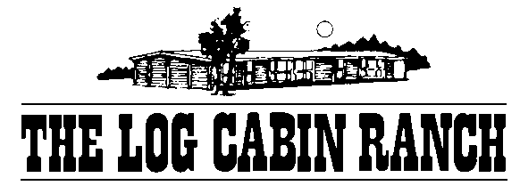

GEMBROOK PRIMARY SCHOOL
Date of Camp 4th and 5th of May 2021
Address
55-57 Rankins Road
Monbulk
PH 0419876986

Child Drop off Procedure

Drop off on -Tuesday the 4th of May at 9.30 /9.45 am
- Enter via David Hill Road end of Rankins Road.
- Enter The Log Cabin Ranch via the first driveway and proceed to the gravel area between the buildings.
- Drop off quickly and then continue along the driveway leaving via the back driveway.
- Turn left down Rankins Road and then right into Emerald\ Monbulk Road to return to Monbulk and travel back to Upwey

Pick up on Wednesday the 5th of May at 2.00 pm
Please follow the same procedure.

